
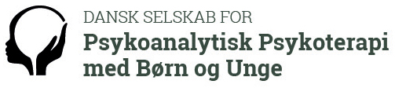

Open for registration
The Danish Society for Psychoanalytic Psychotherapy with Children and Adolescents is celebrating its 25th anniversary in 2017.
September 15th and 16th in Copenhagen
You - Me - and All the Others
We are always more than two – reflections on triangular relationships
Main speakers
Margaret Rustin
Michael Rustin
Liselotte Grünbaum

Themes about
Oedipal conflicts, sibling relations, research methods in psychodynamic case studies.

The seminar will be a combination of paper presentations, live clinical presentations, reflective supervision and small discussion groups. Gala Dinner Friday night included.

Registration
We have now opened for registration – please note our special early bird price for registration before May 1st. Latest registration is July 1st.
Please look at the website for registration and further information.

The venue of the conference
Schæffergården just north of Copenhagen. http://www.schaeffergaarden.dk/.

Hotel booking
You can book rooms at Schæffergården. The venue is located near Copenhagen and it is easy to travel between Copenhagen and Schæffergaarden for the conference. For further recommendations – www.dspbu.dk.

Program
The details of the program of the conference will be announced in May.
The conference takes place Friday from 9:00 till 16:00 and end the day with a conference dinner (included in the fee) starting from 18.30. Saturday starts off at 9:00 and we end the conference at 14.30.

